**How to compare two JSON have same properties without order?**

1. **Let obj1 = {name:” person 1”, age:5};**
2. **Let obj2 = {age:5, name:” person 1”};**

**Solution on below Image:**

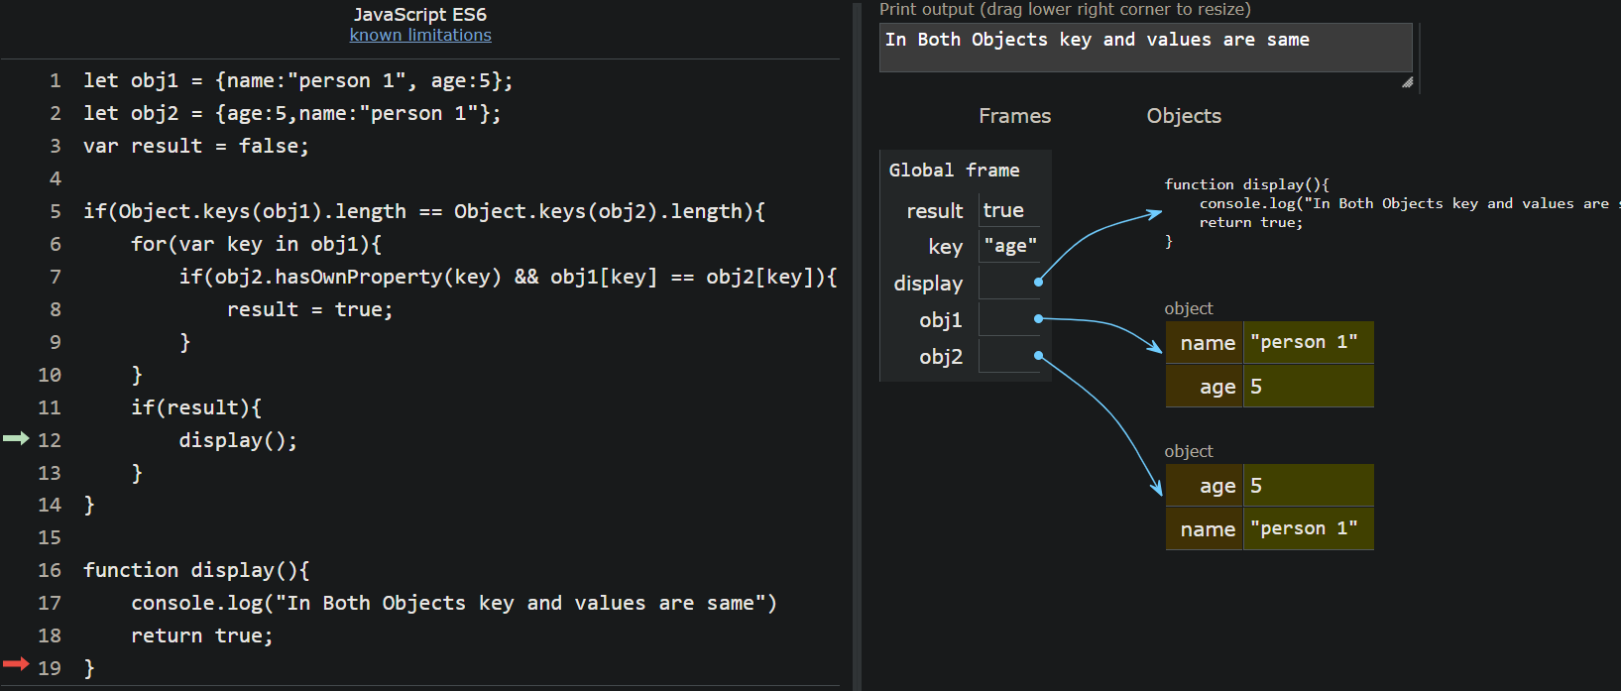

**let obj1 = {name:"person 1", age:5};**

**2 let obj2 = {age:5,name:"person 1"};**

**3 var result = false;**

**4**

**5 if(Object.keys(obj1).length == Object.keys(obj2).length){**

**6 for(var key in obj1){**

**7 if(obj2.hasOwnProperty(key) && obj1[key] == obj2[key]){**

**8 result = true;**

**9 }**

**10 }**

**11 if(result){**

**12 display();**

**13 }**

**14 }**

**15**

**16 function display(){**

**17 console.log("In Both Objects key and values are same")**

**18 return true;**

**19 }**